COLEMAN UNIVERSITY Computer Information Systems Name: Michael Fetick
COM 280 Object Oriented Analysis and Design Student No. 84270
NOTE: The Syllabus, the Course Schedule and the Student Manual were provided only on a hard-copy media. I have not transferred my written notes on this topic to text yet.
Class Diagram
My Notes
A UML class diagram describes the object and information structures used by your application, both internally and in communication with its users. It describes the information without reference to any particular implementation. Its classes and relationships can be implemented in many ways, such as database tables, XML nodes, or compositions of software objects.
Note
This topic is about UML class diagrams. There is another kind of class diagram, the .NET class diagram, which is used to visualize program code. For more information, see Designing and Viewing Classes and Types.
To create a UML class diagram, on the Architecture menu, choose New Diagram. For more information about how to draw UML class diagrams, see UML Class Diagrams: Guidelines. For more information about how to create and draw modeling diagrams, see How to: Edit UML Models and Diagrams.
Reading Class Diagrams

The table in this section describes the elements that you can see on a UML class diagram. For information about the properties of these elements, see the following topics:
- Properties of Types in UML Class Diagrams
- Properties of Attributes in UML Class Diagrams
- Properties of Operations in UML Class Diagrams
- Properties of Associations in UML Class Diagrams
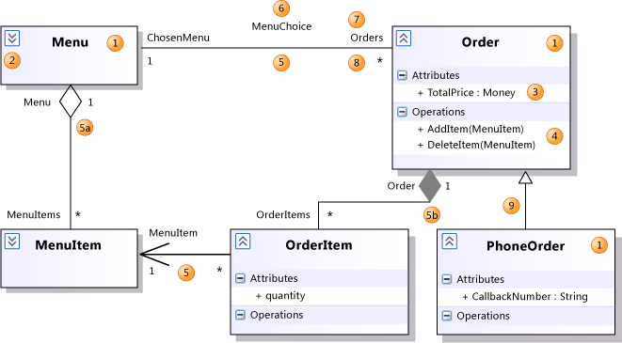
Shape | Element | Description
1 | Class | A definition of objects that share given structural or behavioral characteristics. For more information, see Properties of Types in UML Class Diagrams.
1 | Classifier | The general name for a class, interface, or enumeration. Components, use cases, and actors are also classifiers.
2 | Collapse/ Expand control | If you cannot see the details of a classifier, click the expander at upper-left of the classifier. You might also have to click the [+] on each segment.
3 | Attribute | A typed value attached to each instance of a classifier.  To add an attribute, click the Attributes section and then press ENTER. Type the signature of the attribute. For more information, see Properties of Attributes in UML Class Diagrams.
4 | Operation | A method or function that can be performed by instances of a classifier. To add an operation, click the Operations section and then press ENTER. Type the signature of the operation. For more information, see Properties of Operations in UML Class Diagrams.
5 | Association | A relationship between the members of two classifiers. For more information, see Properties of Associations in UML Class Diagrams.
5a | Aggregation | An association representing a shared ownership relationship. The Aggregation property of the owner role is set to Shared.
5b | Composition | An Association representing a whole-part relationship. The Aggregation property of the owner role is set to Composite.
6 | Association Name | The name of an association. The name can be left empty.
7 | Role Name | The name of a role, that is, one end of an association. Can be used to refer to the associated object. In the previous illustration, for any Order O, O.ChosenMenu is its associated Menu.  Each role has its own properties, listed under the properties of the association.
8 | Multiplicity | Indicates how many of the objects at this end can be linked to each object at the other. In the example, each Order must be linked to exactly one Menu.  * means that there is no upper limit to the number of links that can be made.
9 | Generalization | The specific classifier inherits part of its definition from the general classifier. The general classifier is at the arrow end of the connector. Attributes, associations, and operations are inherited by the specific classifier.  Use the Inheritance tool to create a generalization between two classifiers.
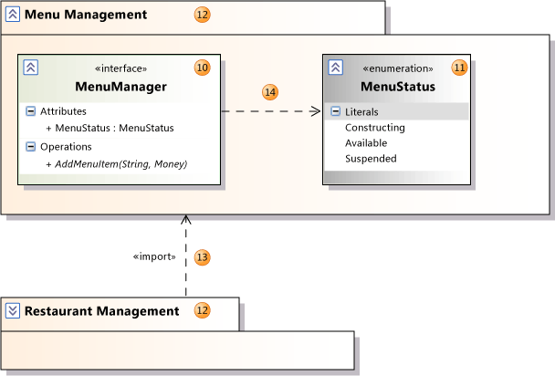
Shape | Element | Description
10 | Interface | A definition of part of the externally visible behavior of an object. For more information, see Properties of Types in UML Class Diagrams.
11 | Enumeration | A classifier that consists of a set of literal values.
12 | Package | A group of classifiers, associations, actions, lifelines, components and packages. A logical class diagram shows that the member classifiers and packages are contained within the package.  Names are scoped within packages so that Class1 within Package1 is distinct from Class1 outside that package. The name of the package appears as part of the Qualified Name properties of its contents.  You can set the Linked Package property of any UML diagram to refer to a package. All the elements that you create on that diagram will then become part of the package. They will appear under the package in UML Model Explorer.
13 | Import | A relationship between packages, indicating that one package includes all the definitions of another.
14 | Dependency | The definition or implementation of the dependent classifier might change if the classifier at the arrowhead end is changed.
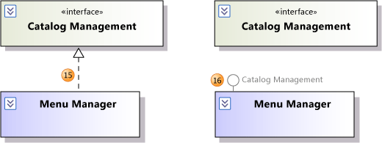
Shape | Element | Description
15 | Realization | The class implements the operations and attributes defined by the interface.  Use the Inheritance tool to create a realization between a class and an interface.
16 | Realization | An alternative presentation of the same relationship. The label on the lollipop symbol identifies the interface.  To create this presentation, select an existing realization relationship. An action tag appears near the association. Click the action tag, and then click Show as Lollipop.

Exercises – Class Diagram
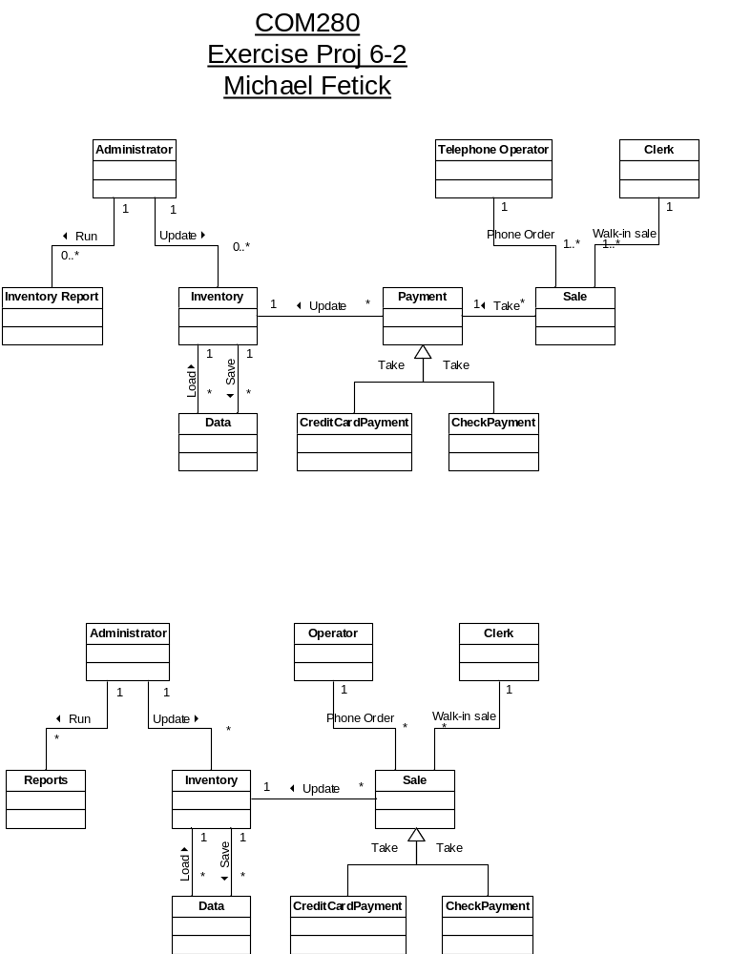
Project 5 – Class Diagram

Class Diagram Exercises

Construct a UML class diagram for each of the following:

- An international airport requires a system to keep track of flight details for customers.
For each flight the system needs to store the flight number, destination, departure time,
departure gate, airline and flight cost. Some flights are direct flights, i.e. they fly non-stop
to the destination and some fly via another airport to their destination. We will call these
flights indirect flights. In this case the flight stops at an airport en route to its destination
to refuel. In the case of indirect flights information regarding the transit airport must also
be stored. The flight cost is calculated to be the cost charged by the airline per
customer plus a percentage of this amount (the profit_rate). In the case of indirect
flights an additional levy must be added to this amount per customer in order to cover
refuelling levies at the transit airport. Furthermore, on some flights additional
passengers can board the plane at the transit airport. The system needs to keep track
of whether boarding will take place at the transit airport or not. The system also needs
to store details of the aircraft used for a flight. The aircraft make, model and capacity
(number of passengers that it can carry), must be stored for each aircraft.

- Suppose that you are required to implement a system for a car dealership. The system
needs to store information about each customer. This includes the customer’s ID
number, name, address and contact number. The dealership sells both used and new
cars. For all cars the registration number, year, make, cost price and selling price must
be stored. The dealership sells both new and used cars. Information regarding the
previous owner, i.e. the contact person’s name and number, must also be stored for
each used vehicle. The selling price of a car is calculated to the cost price plus a
percentage markup of the cost price, i.e. selling price = cost price + cost price x markup
percent.

- A bank manages a number of customer accounts. A customer can have one of three
types of accounts, namely, a current account, a savings account or a loan account.
Details that need to be stored for each customer include the customers ID number,
name, address and telephone number. Each account has an account number and
balance. Money can be withdrawn from an account or deposited into the account. In
the case of both the savings and cheque accounts a withdrawal results in the balance
being decreased while in the case of a loan account the balance is increased. Similarly,
a deposit results in the balance being increased for the cheque and savings accounts
and decreased for the loan account. For each cheque account the customer’s profile,
can be gold, silver or bronze. This information needs to be stored for each cheque
account as accounts in these different categories have different benefits. Whenever a
deposit is made into a savings account the customer earns interest on the updated

Requirements:
• Do use different types of relationships (e.g., aggregation, inheritance, uni-directional and bi-directional associations).
• For all relationships set cardinality (multiplicity) and other necessary parameters.
• Do make attributes of the classes visible before printing out the diagram.
• All attributes must have a correct data type set (e.g., string, date, etc).
• Do follow the naming convention (the rules are listed at the end of the document)

Hints:
• If several classes have common attributes or methods, then make a superclass that has common attributes and methods, and link original classes to this superclass.
• A class can be associated with itself (can have reflexive relationships).
• If class A is a part of class B, use basic aggregation between them (empty diamond shape).
• If an instance of class A has to be related to several instances of class B, use associations with multiplicity (e.g. the requirement “project manager can supervise multiple projects at the same time” tells that multiplicity of the relationship of “project manager” and “project” classes is one-to-many).
• Make several iterations to refine you solution.

UML Naming conventions for class diagram:

Class names
• Starts with an uppercase letter
• Starts with a noun
• Every word that composes the name starts with an uppercase letter
• Words are run together (e.g., DomainManager)

Methods and attributes
• Starts with a lowercase letter
• Method’s name starts with a verb
• Attribute’s name starts with a noun
• Words are run together (e.g., getApplications)
• Every word that composes the name starts with an uppercase letter (except the first one)

Associations
• Starts with an uppercase letter
• Starts with a verb
• Every word that composes the name starts with an uppercase letter
• The name of an association should not be a concatenation of the names of the messages that the classes can exchange. So an association name like "registers itself, devices, and services to" is not a proper association name.

5 points

Due date: Tuesday July 9, 2013 11:30 p.m. PDT.

COLEMAN UNIVERSITY Computer Information Systems Name: Michael Fetick
COM 280 Object Oriented Analysis and Design Student No. 84270
